MTH 325 Fall 2024 – Exam 1

Instructions: Complete your work in the spaces provided below each set of Skill questions. The criteria for Mastery level on each Skill is: **Each part of the problem has a response that is free from significant errors, has correct answers, and each answer is supported by a clear explanation either in English or in mathematical steps that are clearly shown**. Note this means, unless otherwise stated, you are required to provide not only correct answers but clear explanations for each response. When you are done, place your name at the top and submit your paper.

A solution guide for this Exam will be posted by early next week; watch your announcements.

**Skill 1:**

**(CORE) I can outline a proof by mathematical induction.**

Consider the following proposition: For every integer $n≥5$, $4n<2^{n}$.

1. State the value of *n* that corresponds to the base case, then prove that the base case holds.
2. Clearly state the inductive hypothesis. Your answer should be phrased as a complete sentence. (No explanation is required here; simply state the inductive hypothesis.)
3. Clearly state what you would need to prove, after assuming the inductive hypothesis. Your answer should be phrased as a complete sentence. (You do not need to give a completed proof the statement; simply state what you would need to prove.)

**Skill 2:**

**(CORE) I can outline a proof using direct, contrapositive, and indirect approaches.**

Consider the following proposition: For all integers *n*, if $n^{5}$ is even then *n* is even.

1. Clearly state what you would assume and what you would need to prove, if you were to prove this statement with a *direct proof*. (No further explanation is necessary.)
2. Clearly state what you would assume and what you would need to prove, if you were to prove this statement with a *proof by contrapositive*. (No further explanation is necessary.)
3. Clearly state all assumptions you would make, if you were to prove this statement with a *proof by contradiction* (also known as an *indirect proof*). (No further explanation is necessary.)

Note: You are not being asked to give completed proofs here. Simply state the frameworks for each type of proof.

**Skill 3**

**(CORE) I can represent a graph in different ways, determine information (degree, degree sequence, paths of given length, etc.) about a graph using different representations, and give examples of graphs with specified properties.**

Consider the graph *G* given by this Python dictionary:

{0: [4, 7], 1: [2, 3, 4, 5, 6], 2: [1, 6], 3: [1, 7], 4: [0, 1, 6],

5: [1, 6, 7], 6: [1, 2, 4, 5], 7: [0, 3, 5]}

1. In the table below, state the degree of each vertex. You don’t need to explain your answers here, just make sure they are right.

|  |  |  |  |  |  |  |  |  |
| --- | --- | --- | --- | --- | --- | --- | --- | --- |
| *v* | 0 | 1 | 2 | 3 | 4 | 5 | 6 | 7 |
| Deg(*v*) |  |  |  |  |  |  |  |  |

1. Find the number of edges in the graph. Show your work or otherwise explain your reasoning.
2. Give an example of a cycle of length 4. If no such cycle exists, say so and explain how you know.
3. Give an example of a walk in this graph, that is not a trail. Explain in one sentence why your example fits the description. If no such walk exists, say so and explain how you know.
4. Give an example of a path of length 10 in this graph. If no such path exists, say so and explain how you know.

**Skill 4**

**I can determine whether a graph has an Euler trail or Euler circuit, and whether a graph has a Hamiltonian path or circuit.**

Consider the graph *G* shown below:

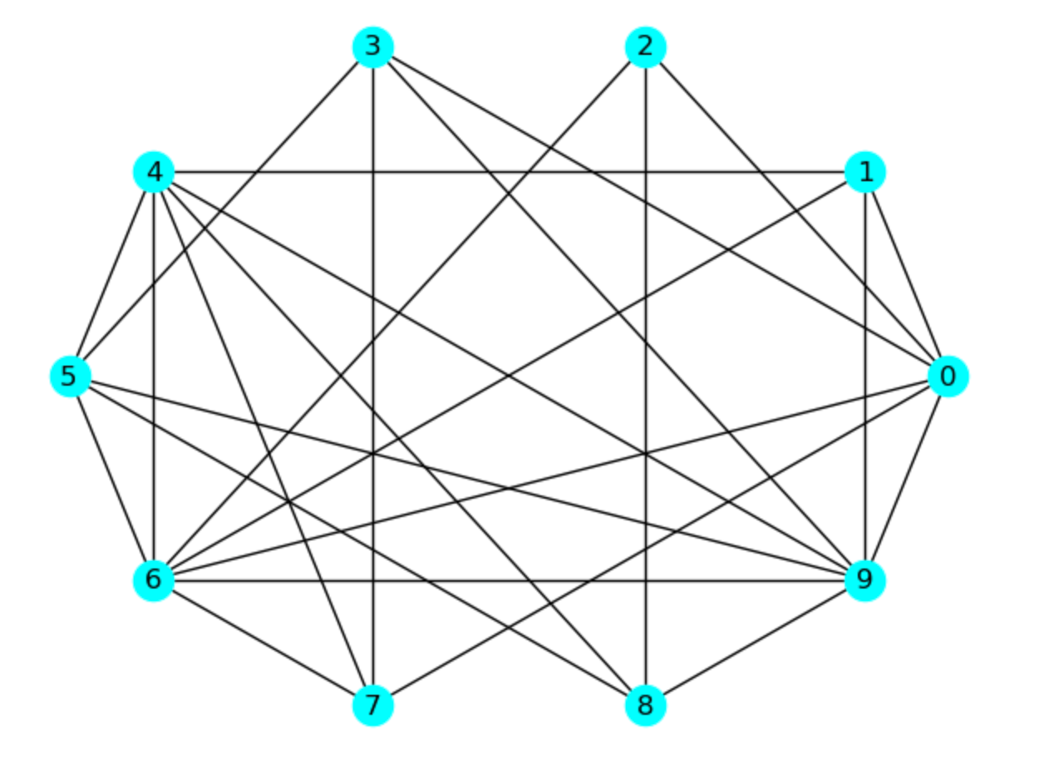

1. Determine whether this graph has an Euler trail, and explain how you know.
2. Determine whether this graph has an Euler circuit, and explain how you know.
3. Determine whether this graph has a Hamilton path, and explain how you know.
4. Determine whether this graph has a Hamilton circuit, and explain how you know.